**Ideation Phase**

**Define the Problem Statements**

|  |  |
| --- | --- |
| Date | 19 September 2022 |
| Team ID | PNT2022TMID31805 |
| Project Name | Personal Expense Tracker Application |
| Maximum Marks | 2 Marks |

**Customer Problem Statement Template:**

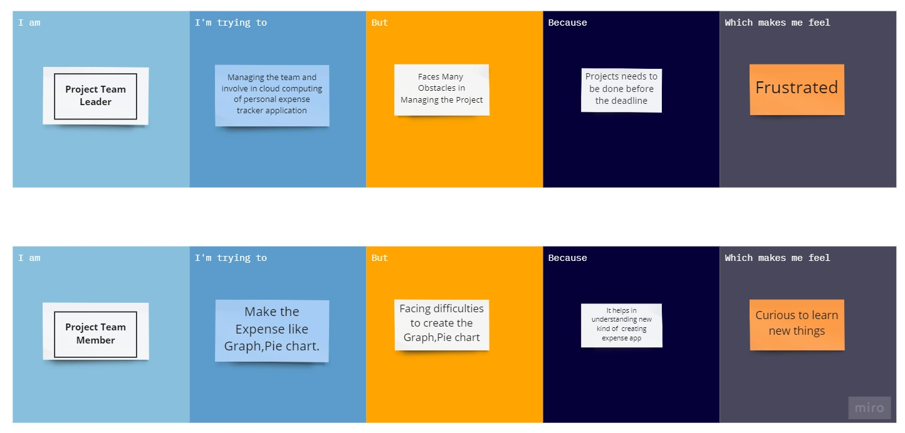

|  |  |  |  |  |  |
| --- | --- | --- | --- | --- | --- |
| **Problem Statement (PS)** | **I am (Customer)** | **I’m trying to** | **But** | **Because** | **Which makes me feel** |
| PS-1 | **Project Team Leader** | Managing the team and involve in cloud computing of personal expense tracker application | Faces Many  Obstacles in Managing the Project | Projects needs to be done before the deadline | Frustrated |
| PS-2 | **Project Team Member** | Make the Expense like Graphs and Pie chart. | Facing difficulties to create the Graphs and Pie chart | It helps in understanding new kind of  creating expense app | Curious to learn new things |